2020 Hamilton Lake status report on the Black Creek Watershed by Pete Hippensteel
In May 2017 unusually high values for both E. coli bacteria and the nutrient phosphorus in the Steuben County Lakes Council’s regular water quality sampling alerted us to the need to take corrective action within the Black Creek Watershed, Hamilton Lake’s largest inflow. In June we took several additional samples to try to pinpoint the source of the pollution. Using the results of these tests we contacted the Steuben County Health Department, the Steuben County Soil and Water District, the Maumee River Commission and the Indiana Department of Environmental Management. After several phone calls and meetings, it became obvious that we needed to take the initiative locally. With the help of local officials and the Steuben County Farm Bureau I was able to meet with the farmers in the watershed to discuss our concerns. I received a positive response from the farmers. During the summers of 2018 and 2019, I along with one of the farmers collected additional samples at critical locations in the watershed to help further identify the sources of the bacteria and phosphorus. These sample sites are indicated by numbers 1a thought 6 on the Hamilton Lake Watershed map. The farmers moved their cattle away from one farm that was an obvious contributor to the runoff problems near sample site 5. Also, they fenced their cattle away from a stream. We are working to provide additional grass buffer filter strips between their cattle operations and the adjacent Black and Fish Creeks.
I have presented this progress at the Hamilton Lake Association’s meeting the past two summers.
This past summer, 2019, we expanded our efforts even further by adding an environmental DNA test to our sampling protocol at four sites. The results of these tests along with our regular sampling indicates that progress is being made. The number of bacteria from cattle in Black Creek has been greatly reduced. Although a new source from pigs was detected. This appears to be a one-time manure application to a field near Black Creek.
The following graph is comparing data from the four sample dates that I collected samples with the farmers over the past two summers. There are areas in the upper portions the watershed that need to implement better manure and nutreint management. But the E.coli bacteria numbers are improving at the Black Creek inflow near State Road 1.
Black Creek is the main tributary (6) carrying water from the east and northeast areas of the watershed. The water quality of this creek has been of concern because of high E. coli, nutrients, and sediment inputs in 2017 and May 2018.
The other smaller streams to the west and north have intermittent flows with low concentrations of pollutants based on previous testing.
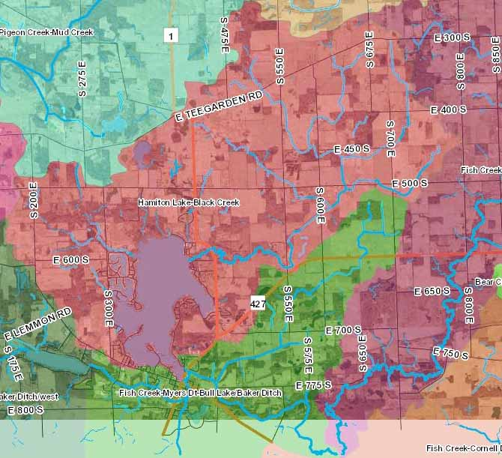
As you can see, the numbers entering Hamilton Lake are improving greatly over the average of the samples taken in 2017 and May 2018.
We are still working with the land-owners in the watershed to protect and improve the water quality of Hamilton Lake.
3
4

1a
Hamilton Lake Watershed
2

1
6
4

5
4

4
4

